Slide 1 — Title Slide
Project: Weather App Deployment on Kubernetes (EKS)
Team Structure
- Group 1: DevOps – CI/CD + Weather App Deployment
- Group 2: SRE – Monitoring (Prometheus, Grafana, n8n)
- Group 3: Cloud Infrastructure – EKS Cluster using Terraform
Presented by: Group 3

Slide 2 — Project Objective
Goal of the Project
Deploy a Weather Application on Kubernetes using AWS EKS with:
- Infrastructure created using Terraform
- CI/CD pipeline for application deployment
- Monitoring using Prometheus and Grafana
- Automation using n8n
- Persistent storage using PVC
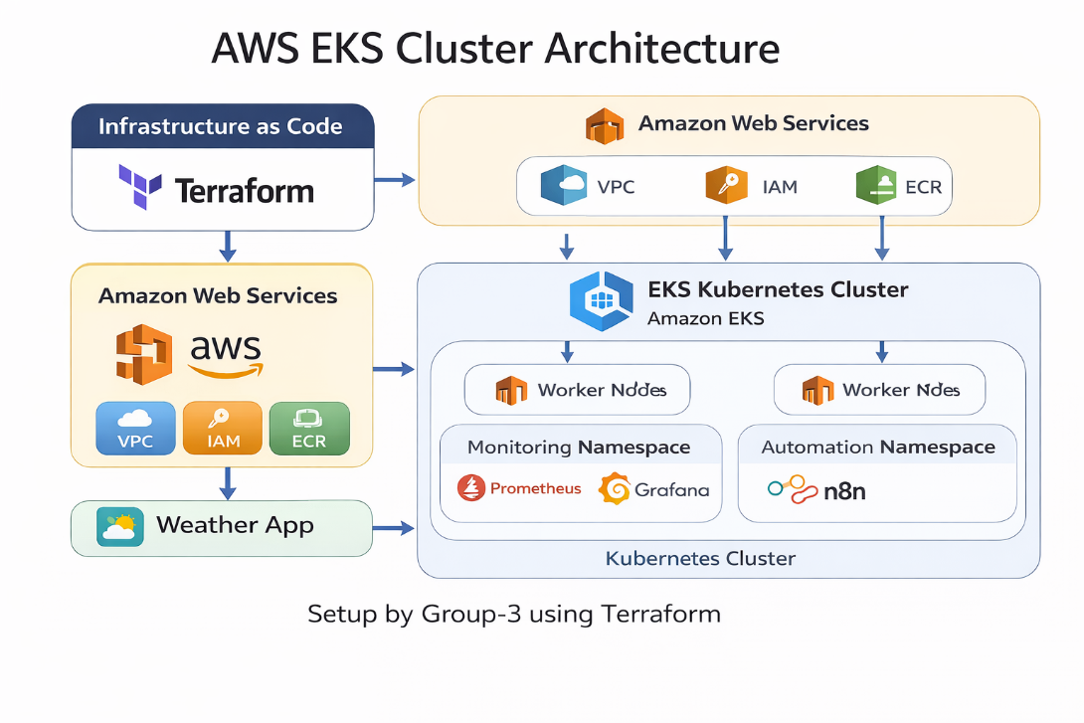

Slide 3 — Responsibilities of Group 3
Cloud & Infrastructure Team Tasks
Our responsibilities were:
✔ Create AWS infrastructure using Terraform
✔ Provision Amazon EKS Kubernetes Cluster
✔ Configure worker nodes
✔ Prepare cluster for application deployment
✔ Create namespaces for monitoring tools
✔ Configure LoadBalancer services

Slide 4 — Infrastructure Architecture
Overall System Architecture
Terraform
│
├── AWS VPC
│ ├── Subnet 1
│ └── Subnet 2
│
├── IAM Roles
│
└── Amazon EKS
│
├── Node Group
│ ├── EC2 Worker Node
│ └── EC2 Worker Node
│
└── Kubernetes Cluster
├── Weather App
├── Prometheus
├── Grafana
└── n8n

Slide 5 — Terraform Project Structure
Infrastructure Code Layout
eks-terraform/
│
├── provider.tf
├── backend.tf
├── variables.tf
│
├── vpc.tf
├── iam.tf
├── eks-cluster.tf
├── node-group.tf
│
├── namespace.yaml
├── loadbalancers.yaml
│
└── outputs.tf

Slide 6 — Infrastructure Deployment
Terraform Commands Used
terraform init
terraform plan
terraform apply
Terraform automatically creates:
- VPC
- Subnets
- Internet Gateway
- IAM roles
- EKS cluster
- Worker node group

Slide 7 — EKS Cluster Setup
Configure kubectl access
Command used:
aws eks update-kubeconfig \
--region ap-southeast-1 \
--name weather-eks
Verify cluster:
kubectl get nodes
Example result:
ip-10-0-1-82.ap-southeast-1.compute.internal
ip-10-0-2-123.ap-southeast-1.compute.internal

Slide 8 — Kubernetes Namespaces
Namespaces created for separation of services:
Namespace | Purpose
monitoring | Prometheus & Grafana
n8n | Automation workflows
Command used:
kubectl apply -f namespace.yaml

Slide 9 — LoadBalancer Configuration
LoadBalancer services created for external access.
Service | Port
Prometheus | 9090
Grafana | 3000
n8n | 5678
Command used:
kubectl apply -f loadbalancers.yaml
AWS automatically provisions Elastic Load Balancers.

Slide 10 — Kubernetes Cluster Verification
Commands used for verification:
kubectl get nodes
kubectl get pods -A
kubectl get ns
kubectl get svc -A
These confirm:
✔ worker nodes are running
✔ Kubernetes system pods are healthy
✔ namespaces exist
✔ services are exposed

Slide 11 — Integration with Other Teams
DevOps Team (Group 1)
Responsible for:
- CI/CD pipeline
- Docker image build
- Weather App deployment
- PVC configuration

SRE Team (Group 2)
Responsible for:
- Prometheus monitoring
- Grafana dashboards
- n8n automation workflows

Slide 12 — Infrastructure Configuration
Component | Configuration
AWS Region | ap-southeast-1
Cluster Name | weather-eks
Node Type | m7i-flex.large
Worker Nodes | 2
Auto Scaling | 1–3 nodes
Namespaces | monitoring, n8n

Slide 13 — Final System Architecture
Terraform
│
└── AWS EKS Cluster
│
├── Weather App
├── Prometheus
├── Grafana
└── n8n
This setup ensures:
✔ scalable infrastructure
✔ automated deployments
✔ monitoring and observability

Slide 14 — Outcome
Group 3 successfully delivered:
✔ Infrastructure as Code using Terraform
✔ Fully functional AWS EKS cluster
✔ Kubernetes worker node setup
✔ Monitoring namespaces and services
✔ LoadBalancer access for monitoring tools

Slide 15 — Demo
Live demonstration commands
kubectl get nodes
kubectl get pods -A
kubectl get svc -A
These commands show:
- running worker nodes
- Kubernetes system pods
- monitoring services

